Chapter 1: Introduction

1.1 Introduction

The used-car market provides an important alternative for individuals and organizations that require personal transportation at a lower cost than a new vehicle. However, the resale price of a used car is influenced by many interrelated factors, including manufacturing year, distance driven, fuel type, transmission, ownership history, engine capacity, maximum power, seating capacity, brand reputation, and model demand. In conventional transactions, these factors are often evaluated manually by dealers or experienced individuals. The resulting price may therefore vary considerably between sellers and may not provide a transparent benchmark to buyers.

This project develops AutoValue, a web-based car resale price prediction system that converts historical vehicle data into an estimated resale price. The system uses a custom Multiple Linear Regression model trained by Mini-Batch Stochastic Gradient Descent. A Flask web application integrates the trained model with data validation, brand and model suggestions, authentication, prediction history, price-range calculation, similar-car recommendations, and administrative reporting. PostgreSQL stores user accounts and estimates, while the training dataset remains in CSV format. The final system is designed to demonstrate the practical integration of machine learning, web development, database management, authentication, and software testing in a single academic project.

1.2 Problem Statement
The used-car valuation process is often subjective and inconsistent because it depends heavily on dealer judgment and limited market information. As a result, similar vehicles may receive different prices, creating information asymmetry and reducing trust between buyers and sellers. This project addresses the problem by developing a web-based, data-driven system that uses measurable vehicle features to generate consistent resale price estimates, store prediction history, protect user accounts, and support administrative monitoring.

1.3 Objectives
- To develop a Multiple Linear Regression model for predicting used car resale prices.
- To create a responsive web application for instant and intuitive price estimation.
- To provide a data-driven valuation tool that reduces bias and improves market transparency.

1.4 Scope and Limitation
Scope:
- The system analyzes twelve vehicle attributes, including brand, model, manufacturing year, usage history, mileage, engine capacity, maximum power, and seating capacity.
- It provides brand and model suggestions, validates user inputs, and generates an estimated resale price in NPR with a price range and similar vehicle recommendations.
- Guest users can obtain predictions, while registered users can save estimates, view prediction history, and record actual purchase prices.
- Administrators can monitor system statistics, manage user and prediction records, and export prediction data as CSV.
- The machine learning pipeline performs data preprocessing, feature engineering, encoding, standardization, and model training using Multiple Linear Regression optimized with SGD.
Limitations:
- The model is trained on historical used-car data converted from INR to NPR using a fixed exchange factor, so predictions may not represent current Nepal market prices.
- The system does not consider physical condition, accident history, service records, location, taxes, import duties, or real-time market demand.
- The linear regression model may not capture all complex relationships between vehicle features.
- The model is retrained when the application starts and is stored only in application memory.
- The purchase-feedback and online model-update features remain experimental when complete vehicle details are unavailable.

1.5 Development Methodology
The project was executed using the Agile Scrum Framework, which facilitated an iterative and flexible development environment suitable for a machine learning project. The process was organized into a series of time-boxed Sprints, each beginning with a Sprint Planning session to define tasks from the product backlog. Daily Stand-ups were utilized to monitor progress and address technical blockers, particularly during the complex phases of data preprocessing and model optimization. At the end of each cycle, a Sprint Review was conducted to demonstrate the working increments, such as the integrated autocomplete module or the validated prediction endpoint. This iterative approach allowed for continuous testing and refinement of the Multiple Linear Regression model, ensuring that the final web application met all functional requirements while maintaining high reliability.

1.6 Report Organization
The report is structured into six chapters to provide a comprehensive overview of the project:
- Introduction
- Background Study and Literature Review
- System Analysis
- System Design
- Implementation and Testing
- Conclusion and Future Recommendations

Chapter 2: Background Study and Literature Review

2.1 Background Study

Used-car valuation is a supervised regression problem in which historical vehicle data is used to estimate a continuous resale price. Unlike new vehicles, used-car prices vary according to age, kilometers driven, mileage, engine capacity, ownership history, brand reputation, and other technical characteristics. Traditional valuation often depends on dealer experience and physical inspection, which can produce inconsistent or biased prices. Machine learning provides a more systematic and repeatable approach by identifying patterns in historical sales data [1], [2].

This project uses Multiple Linear Regression optimized through Stochastic Gradient Descent to estimate resale prices from vehicle features. Numerical data is cleaned and standardized, while categorical attributes such as fuel type and transmission are encoded before training. A logarithmic transformation is applied to the selling price to reduce skewness, and the predicted value is converted back into NPR.

The trained model is integrated into a Flask-based web application so that non-technical users can obtain predictions through a browser. Flask handles requests and validation, Flask-Login manages user authentication, SQLAlchemy connects the application with PostgreSQL, and JavaScript supports client-side validation and brand-model suggestions. Together, these technologies provide an accessible, data-driven vehicle valuation system.

2.2 Literature Review
Raghav [1] discusses the use of machine learning for used-car price prediction and emphasizes the importance of vehicle attributes such as year, mileage, engine characteristics, and brand. The study supports the general approach of converting historical listing data into a predictive model, although the reliability of the final result remains dependent on data quality and preprocessing.
Lessmann and Voß [2] conducted a comparative study of resale-price forecasting methods and reported that model choice, heterogeneity, and access to private information materially affect forecasting performance. Their results showed that non-linear methods such as random forests can outperform ordinary linear regression. This finding is relevant to the present project because it establishes a realistic limitation of the selected linear baseline. The project nevertheless uses a custom linear model to provide interpretability, computational simplicity, and full control over the optimization process, while identifying non-linear methods as future work.
Abdullah et al. [3] investigated machine learning models for predicting reconditioned-car selling prices. Their work demonstrates the usefulness of machine learning for buyers, sellers, dealerships, and other market participants. It also reinforces the need to compare models using regression metrics rather than relying on a single general accuracy value.
Gegic et al. [4] compared Artificial Neural Networks, Support Vector Machines, and Random Forests for car-price prediction and integrated the resulting model into an application. Their research highlights data collection, cleaning, attribute transformation, model comparison, and interface integration as major parts of a practical prediction system. The reported evaluation also illustrates that the effectiveness of a model depends on the structure of the available dataset.
Monburinon et al. [5] compared several supervised regression methods on used-car market data. Gradient-boosted regression trees and random forests performed better than Multiple Linear Regression in their experiment, while linear regression remained a useful interpretable benchmark. Their comparative approach supports the use of MAE, RMSE, and related metrics for evaluating regression models.

2.2.1 Research Gap and Project Contribution
The reviewed studies mainly compare prediction models, while this project develops a complete academic system around a custom regression algorithm. Beyond model training, it includes a responsive web interface, dataset-based validation, preprocessing, a custom SGD regressor, MAE-based price ranges, similar-car recommendations, authentication, prediction history, purchase-price feedback, an admin dashboard, CSV export, PostgreSQL storage, migrations, and deployment support.
The project also examines practical issues that are often overlooked in literature, such as model integration with authentication, persistent storage, role-based access, and user feedback. It documents limitations related to missing-value handling, categorical alignment, incomplete vehicle records, and synchronization of the in-memory model across multiple workers.
Therefore, the system is presented as an interpretable and reproducible baseline rather than the best possible pricing model. Since ensemble and non-linear methods often outperform linear regression on complex vehicle datasets [2], [4]-[6], the implemented model provides a transparent foundation for future comparison and improvement.

Chapter 3: System Analysis

3.1 System Analysis
The system analysis phase identifies the technical requirements and logical constraints necessary to build an automated car valuation tool. This stage focuses on transforming the subjective elements of the used car market into a structured computational model using Multiple Linear Regression (MLR) and Mini-Batch Stochastic Gradient Descent (SGD). The completed implementation contains three user roles: guest users, authenticated users, and administrators. It also contains two persistent data sources: PostgreSQL for application records and UsedCars.csv for model training and reference comparison. The trained pipeline and model are maintained in application memory after startup.

3.1.1 Requirement Analysis
This section specifies the core functions and quality standards the system must meet to ensure reliable price estimations.
Functional Requirements
- Public Access and Vehicle Input: The system provides public pages such as Home, About, Estimator, and Model Metrics. Users can enter twelve vehicle details required for prediction.
- Validation and Suggestions: The system validates required fields, allowed values, numeric ranges, and brand-model combinations. It also provides real-time brand and model suggestions.
- Price Prediction: The system preprocesses valid vehicle data and generates an estimated resale price in NPR using the trained regression model.
- Price Range and Similar Cars: The system displays a lower and upper price range based on MAE and recommends up to five similar vehicles.
- Authentication and History: The system supports signup, login, logout, password hashing, and session management. Registered users can save and review prediction history.
- Purchase Feedback and Administration: Users can record actual purchase prices, while administrators can view statistics, user records, prediction records, and export data as CSV.
- Model Initialization: The system loads the dataset, trains the model, calculates evaluation metrics, and prepares catalogue data during application startup.
Use Case Diagram
The Use Case Diagram presents the interactions of guest users, registered users, and administrators with the implemented application. Dataset upload and manual model-training use cases from the mid-defense design were removed because the final source code does not provide such administrator interfaces. Model training is executed automatically when the application module is imported.
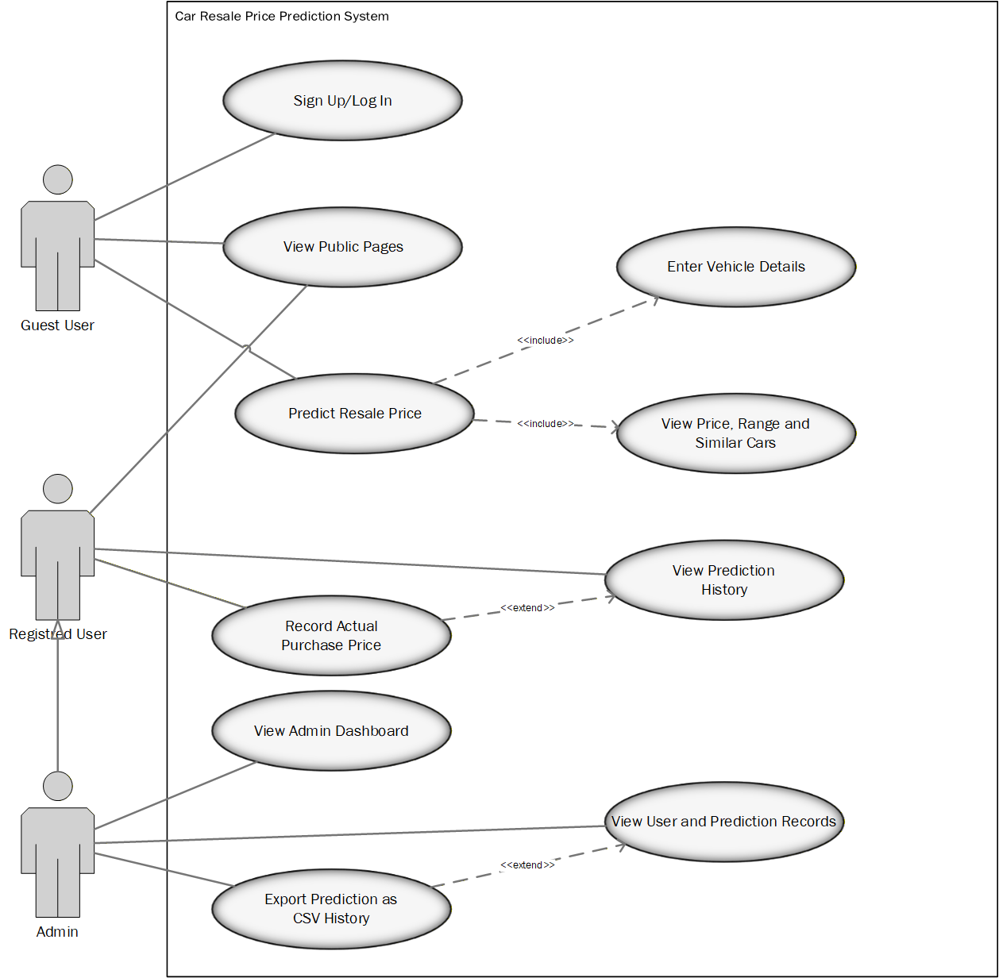

Figure 3.1 Use Case Diagram of Car Resell Price Prediction System
Descriptive Use Case
Table 3.1: Use Case Description for Sign Up / Log In
Use Case Identifier | UC-001
Primary Actor | Guest User
Secondary Actor | None
Pre-condition | The user is not authenticated.
Post-condition | A new account or authenticated session is created.
Failure Scenario | Invalid or duplicate credentials display an error message.

Table 3.2: Use Case Description for View Public Pages
Use Case Identifier | UC-002
Primary Actor | Guest User or Registered User
Secondary Actor | None
Pre-condition | The application is available.
Post-condition | The selected public page is displayed.
Failure Scenario | The page fails to load because of a server error.

Table 3.3: Use Case Description for Predict Resale Price
Use Case Identifier | UC-003
Primary Actor | Guest User or Registered User
Secondary Actor | None
Pre-condition | The estimator page and trained model are available.
Post-condition | The predicted price, price range, and similar cars are displayed.
Failure Scenario | Invalid vehicle details or a prediction error prevents estimation.
Table 3.4: Use Case Description for Enter Vehicle Details
Use Case Identifier | UC-004
Primary Actor | Guest User or Registered User
Secondary Actor | None
Pre-condition | The user is on the estimator page.
Post-condition | Valid vehicle details are submitted for prediction.
Failure Scenario | Missing or invalid details produce validation errors.

Table 3.5: Use Case Description for View Price, Range and Similar Cars
Use Case Identifier | UC-005
Primary Actor | Guest User or Registered User
Secondary Actor | None
Pre-condition | A resale price has been successfully predicted.
Post-condition | The estimated price, MAE-based range, and similar vehicles are displayed.
Failure Scenario | The result cannot be displayed because prediction processing fails.

Table 3.6: Use Case Description for View Prediction History
Use Case Identifier | UC-006
Primary Actor | Registered User
Secondary Actor | None
Pre-condition | The user is authenticated.
Post-condition | Saved predictions are displayed from newest to oldest.
Failure Scenario | A database error prevents the history from loading.
Table 3.7: Use Case Description for Record Actual Purchase Price
Use Case Identifier | UC-007
Primary Actor | Registered User
Secondary Actor | None
Pre-condition | The selected estimate belongs to the authenticated user.
Post-condition | The actual price is stored, and the estimate is marked as bought.
Failure Scenario | Invalid price or unauthorized access prevents the update.

Table 3.8: Use Case Description for View Admin Dashboard
Use Case Identifier | UC-008
Primary Actor | Administrator
Secondary Actor | None
Pre-condition | The administrator is authenticated.
Post-condition | System statistics and recent predictions are displayed.
Failure Scenario | Unauthorized access is rejected or redirected to login.

Table 3.9: Use Case Diagram for View User and Prediction Records
Use Case Identifier | UC-009
Primary Actor | Administrator
Secondary Actor | None
Pre-condition | The administrator has accessed the protected admin area.
Post-condition | User and prediction records are displayed.
Failure Scenario | Unauthorized access or a database error prevents record retrieval.

Table 3.1.1: Use Case Description for Export Prediction History as CSV
Use Case Identifier | UC-010
Primary Actor | Administrator
Secondary Actor | None
Pre-condition | The administrator is authenticated, and prediction records exist.
Post-condition | Prediction history is generated and downloaded as a CSV file.
Failure Scenario | Export fails because of authorization or data-retrieval errors.

Non-Functional Requirements:
- Performance: The system should process valid prediction requests quickly and display the estimated price, price range, and similar vehicles with minimal delay.
- Usability: The interface should be simple, responsive, and easy to use. Forms, suggestions, validation messages, and results should be clear to both technical and non-technical users.
- Reliability: The application should handle invalid inputs, missing values, database errors, and failed requests without affecting the overall system.
- Security: The system should protect passwords through hashing, manage authenticated sessions securely, validate CSRF tokens, and restrict administrative functions based on user roles.
- Maintainability: The application should use organized modules, database migrations, reusable templates, and consistent naming so that future updates can be implemented easily.
- Scalability: The system should support an increasing number of users, predictions, and vehicle records without requiring major changes to the application structure.
- Compatibility: The web application should operate through standard modern browsers and adapt to desktop, tablet, and mobile screen sizes.

3.1.2 Feasibility Analysis
The feasibility study evaluates the project's viability across multiple dimensions to ensure successful deployment within the defined scope.
Technical Feasibility: The system is technically feasible because it is implemented with mature open-source technologies. Python, Flask, Pandas, NumPy, SQLAlchemy, PostgreSQL, HTML, CSS, and JavaScript provide the required capabilities. The custom pipeline and SGD regressor demonstrate that the mathematical model can be implemented without depending on a prebuilt regression estimator.
Operational Feasibility: Users interact with the system through familiar web forms. The estimator provides immediate feedback, while accounts and history support repeated use. Administrative reporting provides basic operational visibility. The completed interface is responsive and can be accessed through a standard desktop or mobile browser.
Economic Feasibility: The primary software components are open source. Development can be performed on an ordinary computer, and the included deployment configurations support low-cost hosting. PostgreSQL and GitHub also have freely available development options suitable for an academic project.
Schedule Feasibility: The work was completed through iterative development. The repository history and final source files show progressive implementation of runtime configuration, database migrations, authentication, administrative pages, model integration, and final documentation.

3.1.3 Data and Process Analysis
The structured analysis approach defines the system through its data entities and the processes that transform inputs into predictive outputs.
3.1.3.1 Data Modelling using ER Diagrams
The Entity-Relationship (ER) Diagram illustrates the logical structure of the data used by the system. In this project, the primary entities include the Vehicle, which contains attributes such as brand, model, and mechanical specifications, and the Prediction, which links these attributes to a calculated resale value. The model defines the relationships between the administrative dataset and the real-time user inputs, ensuring that the data remains consistent throughout the estimation process.

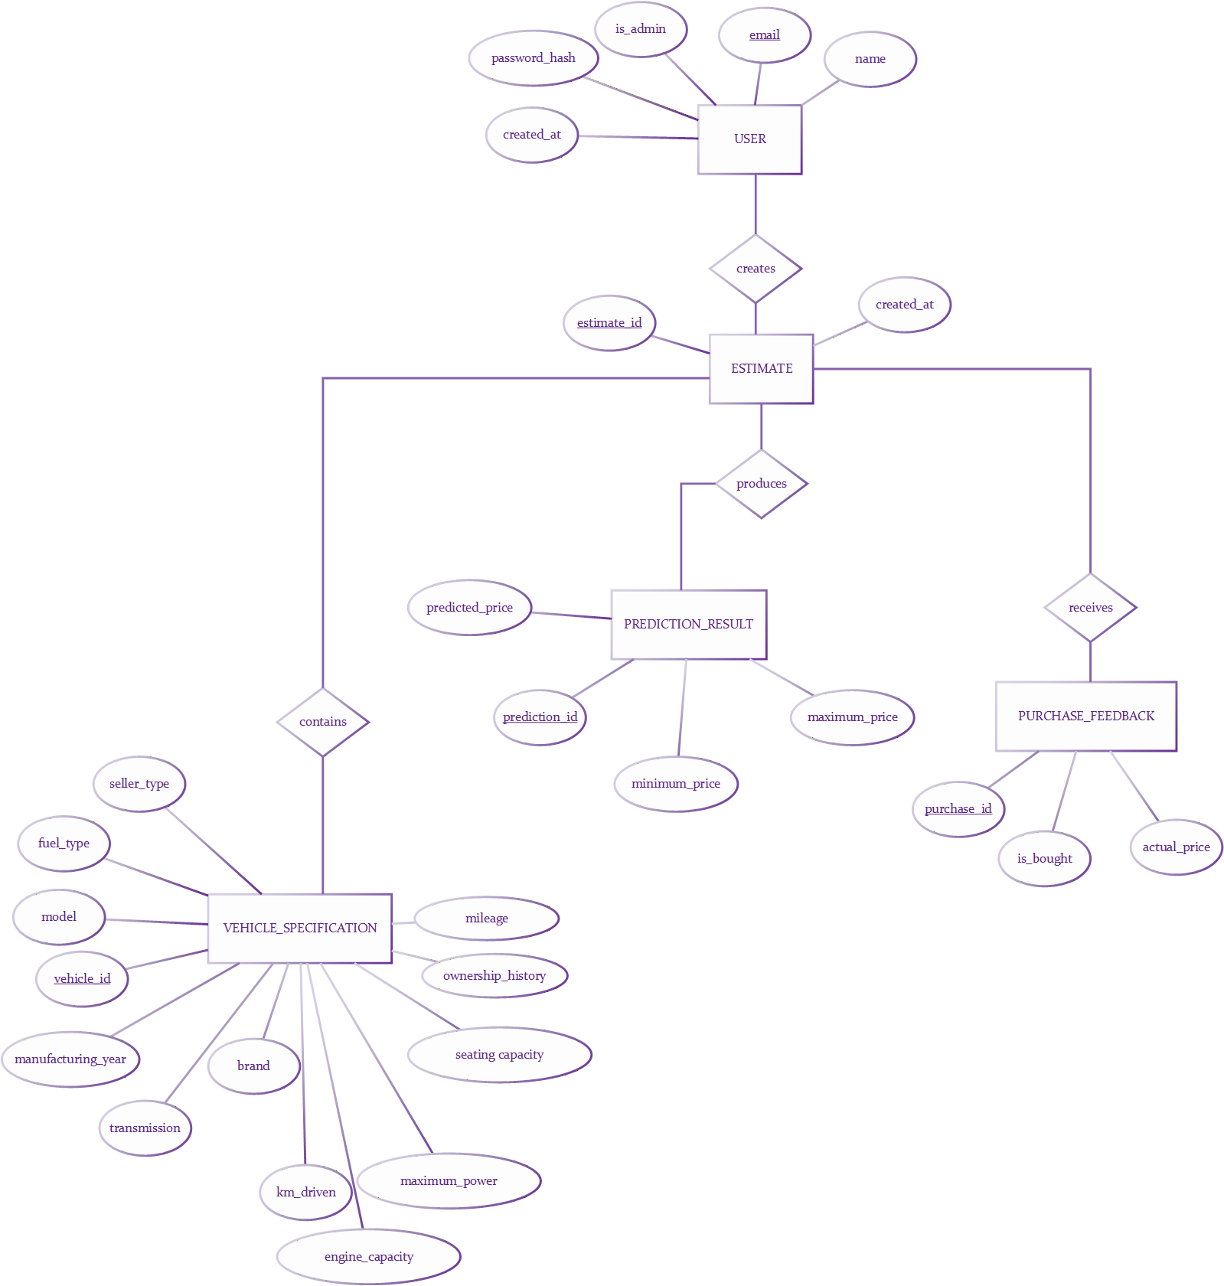
Figure 3.2: ER Diagram for Car Resale Price Prediction System

3.1.3.2 Process Modelling using DFD Diagrams
Context Diagram (Level 0): This high-level view establishes the system boundaries, showing the Car Buyer/Seller providing vehicle details and the System Administrator managing the datasets and model updates.
DFD Level 1: This level partitions the system into four major functional modules: Prediction Request Handling, Data Acquisition, Model Training, and System Administration, while identifying the primary data stores for the training set and model weights.
DFD Level 2: This diagram focuses on the granular steps of the prediction process, detailing the flow from initial Input Validation and Feature Encoding to the final Price Execution and response formatting.
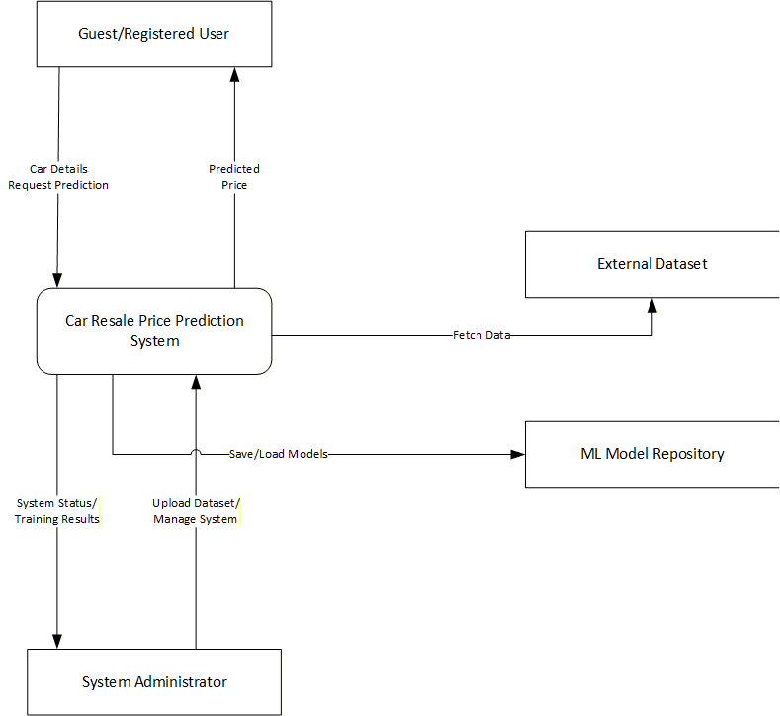
Figure 3.3 DFD level 0 Diagram

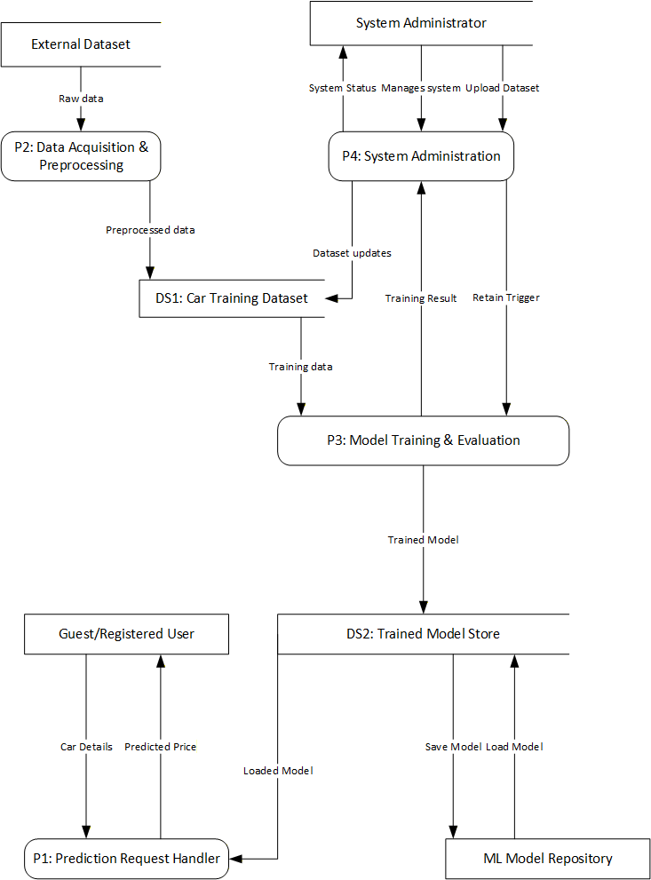
Figure 3.4 DFD level 1 Diagram

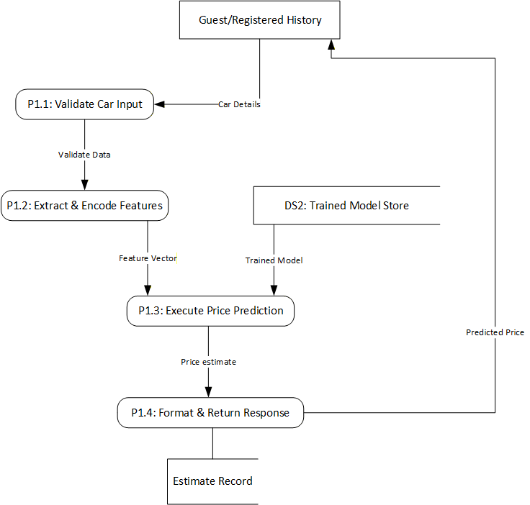
Figure 3.5 DFD level 2 Diagram

CHAPTER 4 – SYSTEM DESIGN

4.1 Design
The design phase transitions the system from conceptual requirements to a structural blueprint. This project utilizes an Object-Oriented Design (OOD) approach to model the interactions between the web-based frontend, the backend middleware, and the mathematical prediction engine.

4.1.1 System Architecture
The project follows a Client-Server Architecture that separates user interaction from backend processing. The browser manages the interface, while the Flask server handles validation, authentication, database operations, and machine learning predictions.
The system operates across four main layers:
- Presentation Layer: This layer consists of HTML, CSS, JavaScript, and Jinja2 templates. It allows users to enter vehicle details, receive brand and model suggestions, view prediction results, manage their accounts, and access prediction history.
- Application Layer: Built using Flask, this layer handles routing, server-side validation, authentication, authorization, session management, prediction requests, administrative functions, and communication between the interface, database, and machine learning model.
- Data Layer: PostgreSQL stores user accounts, prediction records, purchase information, and administrative data. Flask-SQLAlchemy manages database operations, while Flask-Migrate handles schema changes. The CSV dataset is used for model training and vehicle catalogue generation.
- Intelligence Layer: This layer contains the preprocessing pipeline and Multiple Linear Regression model optimized using Stochastic Gradient Descent. It transforms vehicle inputs, generates the predicted resale price, calculates the MAE-based price range, and identifies similar vehicles.
This layered architecture improves system organization and allows the web interface, database, and prediction model to work together efficiently.

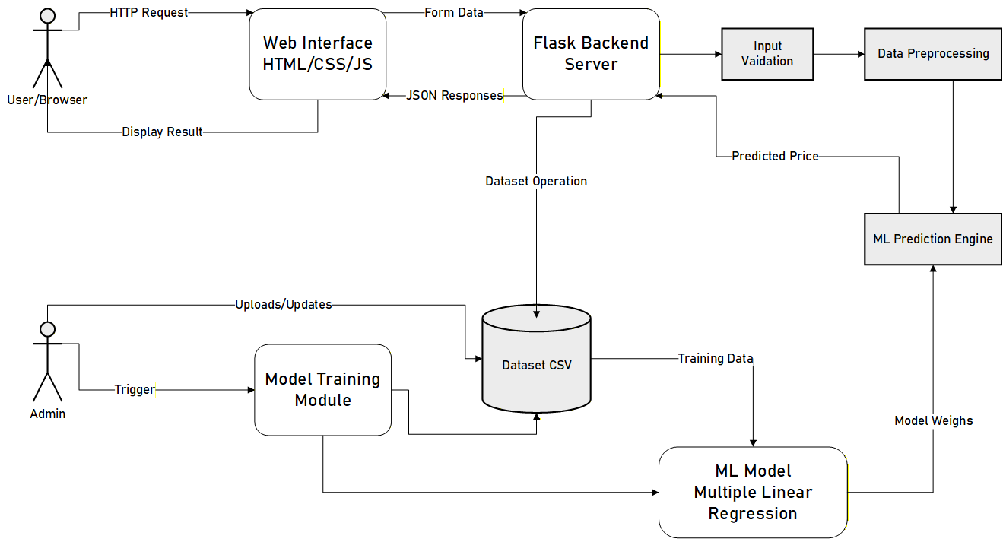

Figure 4.1 System Architecture Diagram for Car Resale Price Prediction System

4.1.2 Object Oriented Design
4.1.2.1 Class Diagram
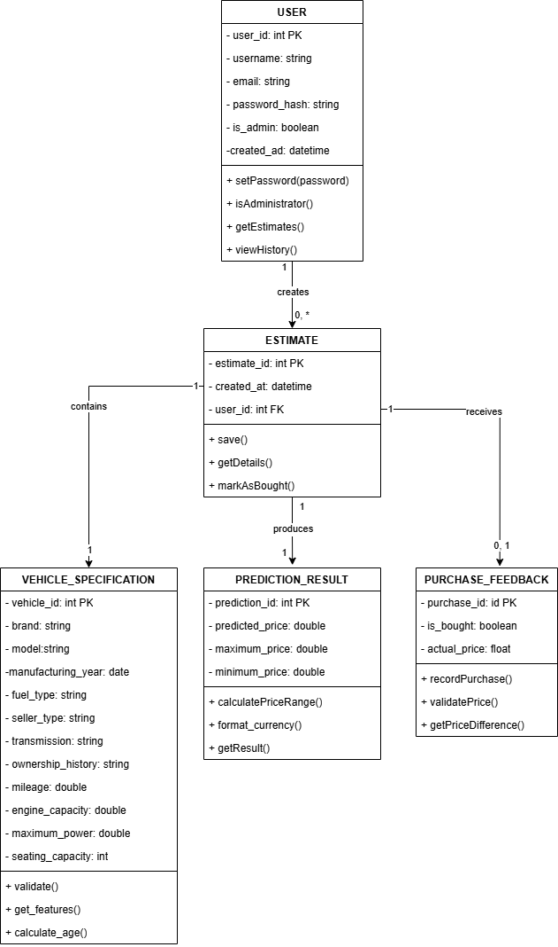
The final Class Diagram is centered on User and Estimate database models, FullPipeline for feature preparation, and SGDRegressor for optimization and inference. Application functions coordinate these classes through Flask routes. The behavioral diagrams show the order of operations during prediction and the user decisions that determine whether a result is stored or later updated with an actual purchase price.

Figure 4.2 Class Diagram for Car Resale Price Prediction System
4.1.2.2 Sequence Diagram
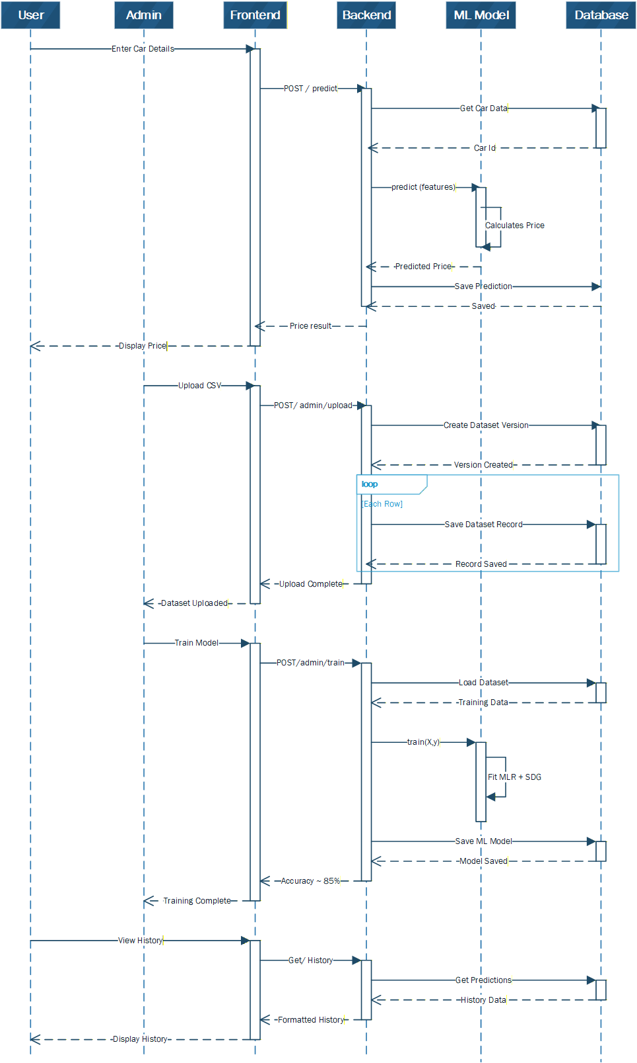
The Sequence Diagram models the chronological interaction between objects. It details the timeline where the browser interface sends an asynchronous request to the server-side controller. The controller then invokes the preprocessing module for scaling and encoding, calls the calculation engine for the final numerical estimation, and returns the result back to the interface for rendering.

Figure 4.3 Sequence Diagram for Car Resale Price Prediction System
4.1.2.3 Activity Diagram
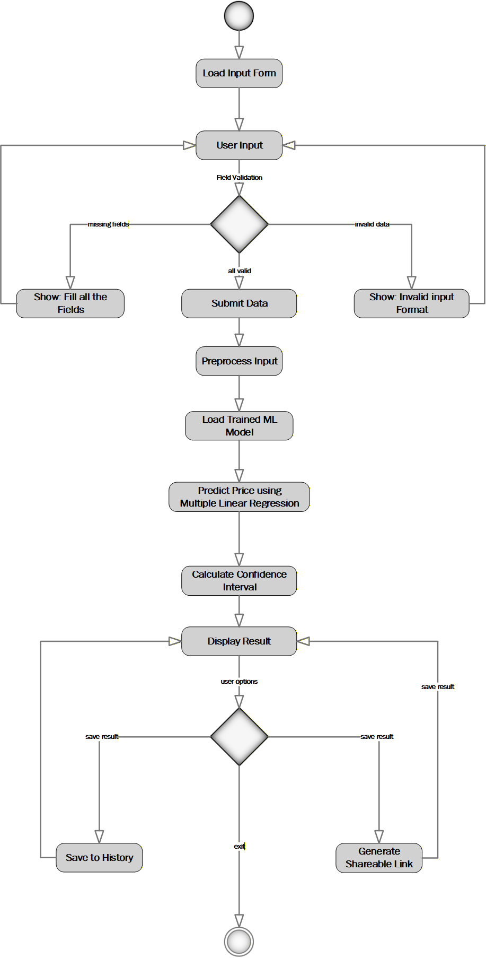
This activity diagram illustrates the workflow of the car resale price prediction system. The process starts when the user loads the input form and enters the required vehicle details. The system validates the input by checking for missing fields and incorrect data formats. If validation fails, appropriate error messages are displayed, and the user is prompted to correct the input before continuing. Once all inputs are valid, the data is submitted, preprocessed, and passed to the trained Multiple Linear Regression model to generate the predicted resale price. The prediction is then saved to the user's history, a confidence interval is calculated to indicate the reliability of the prediction, and the final result is displayed to the user, after which the process ends.

Figure 4.4 Activity Diagram for Car Resale Price Prediction System
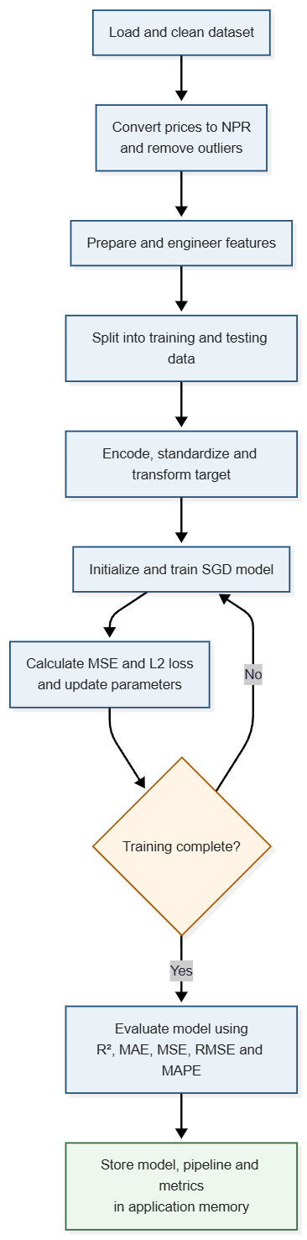
4.1.2.4 Model Training and Implementation Flowchart

Figure 4.5 Model Training and Implementation Flowchart
4.1.3 Training, Component and Deployment Diagram
4.1.3.1 Component Diagram
The Component Diagram describes the modular organization of the software. The system is divided into three primary components: the Client Interface (UI logic), the Application API (routing and validation), and the Inference Logic (mathematical computations). These components are decoupled, allowing the interface to be updated independently of the underlying regression weights.
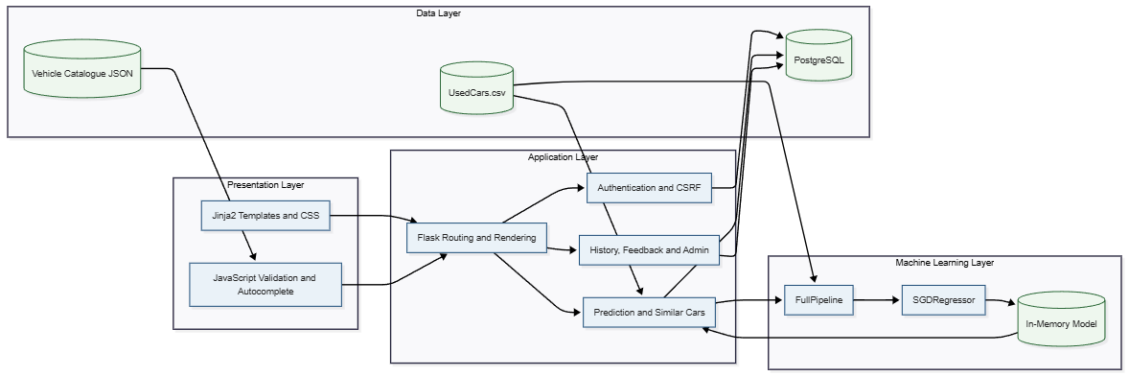
Figure 4.6 Component Diagram

4.1.3.2 Deployment Diagram
The Deployment Diagram shows the physical execution environment of the project. It maps the software components to hardware nodes, involving a Client Node (Web Browser) and a Server Node (Application Server). It illustrates how the dataset and catalog files are stored as local resources on the server node to be accessed by the application during execution.
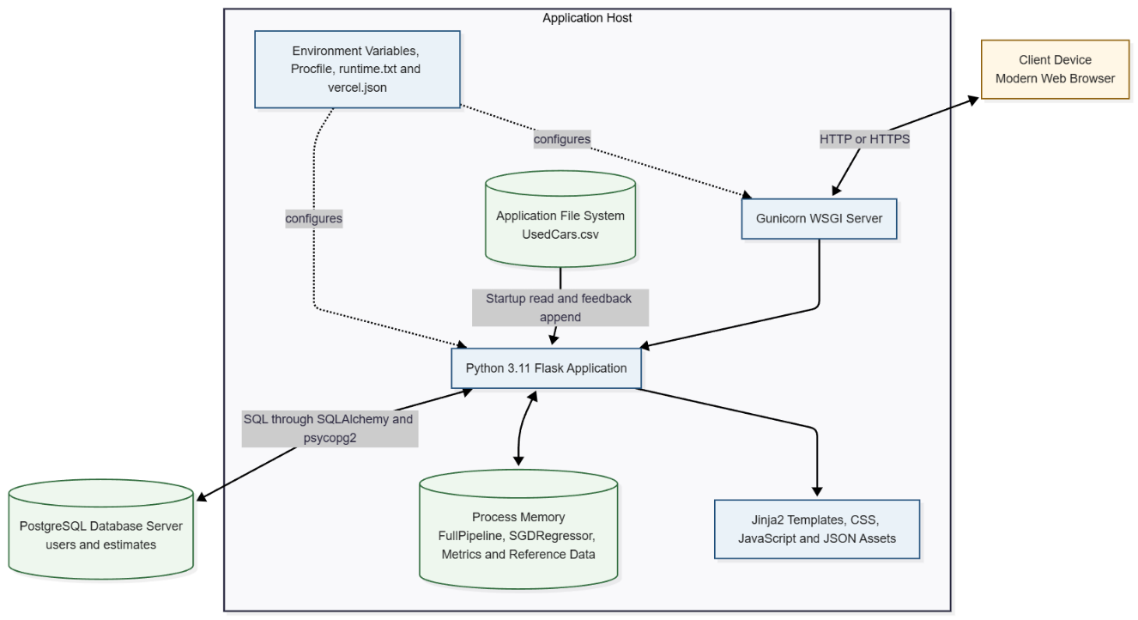
Figure 4.7 Deployment Diagram

4.2 Algorithm Details
The system utilizes Multiple Linear Regression (MLR) as the primary predictive model. To ensure high computational efficiency and scalability, the model is optimized using Mini-Batch Stochastic Gradient Descent (SGD). This combination allows the system to process vehicle features and estimate resale values with a high degree of statistical accuracy.

4.2.1 Data Preparation
The application uses UsedCars.csv, containing 8,131 records and 13 original attributes. Selling prices are converted to NPR using a factor of 2.2. During preprocessing, duplicate rows and the inconsistently formatted torque column are removed. Brand and model are extracted from the vehicle name, while mileage, engine capacity, and maximum power are converted into numeric values. Price outliers below the 1st percentile and above the 99th percentile is excluded, and less frequent models are grouped as Other. After preprocessing, 6,789 records remain.
The dataset is divided into 80% training and 20% testing data using random_state=42, resulting in 5,431 training records and 1,358 testing records. After feature engineering and one-hot encoding, the pipeline produces 1,942 feature columns.
4.2.2 Feature Engineering
Table 4.1 Engineered Feature Description
Feature | Formula or Logic | Purpose
car_age | CURRENT_YEAR - year | Represents age-related depreciation.
km_per_year | km_driven / (car_age + 1) | Measures average annual use and avoids division by zero.
is_7_seater | 1 if seats >= 7, otherwise 0 | Indicates larger seating capacity.
engine_power_ratio | engine / (max_power + 1) | Represents the relationship between displacement and power.
power_per_cc | max_power / (engine + 1) | Measures power output per unit of engine capacity.
is_luxury | 1 for BMW, Audi, Mercedes-Benz, Jaguar, Land, or Volvo | Represents premium-brand positioning.
After feature engineering, the target column is removed from the input matrix. Categorical variables are expanded using one-hot encoding with drop_first=True. Numeric training values are filled with column means and standardized by subtracting the training mean and dividing by the training standard deviation. The training column list is stored so that later inputs can be aligned to the same feature order.
4.2.3 Multiple Linear Regression Model
For an input vector x_i containing p processed features, the model predicts the logarithm of the resale price as a linear combination of feature weights and an intercept:
ẑᵢ = wᵀxᵢ + b = b + Σⱼ₌₁ᵖ wⱼxᵢⱼ
where ẑᵢ is the predicted log-price for observation i, xᵢⱼ is feature j, wⱼ is the learned coefficient for that feature, and b is the intercept. The actual price yᵢ is transformed before training as follows:
zᵢ = ln(1 + yᵢ)
The logarithmic transformation reduces the influence of very large price values and helps the linear model represent a positively skewed target. After prediction, the system returns to the original NPR scale using:
ŷᵢ = exp(ẑᵢ) – 1
4.2.3 Loss Function and Mathematical Derivation of the Gradients
The implemented SGDRegressor minimizes Mean Squared Error with L2 regularization. For a mini-batch B containing m observations, the objective function is:
J_B(w, b) = (1/m) Σᵢ∈B (wᵀxᵢ + b - zᵢ)² + λ ||w||₂²
The first term is the average squared prediction error in logarithmic price space. Squaring makes all errors non-negative and gives larger errors a greater penalty. The second term is the L2 penalty. It discourages excessively large coefficients and reduces sensitivity to noisy or highly correlated encoded features. The intercept b is not regularized in the implemented algorithm. The variables are defined as follows:
• J_B(w, b): total objective value for the current mini-batch.
• m: number of observations in the current mini-batch.
• xᵢ: processed feature vector for observation i.
• zᵢ: actual log-transformed selling price ln(1 + yᵢ).
• w: vector of regression coefficients.
• b: scalar intercept.
• λ: L2 regularization strength; λ = 0.01 in the implementation.
• ||w||₂²: sum of squared coefficient values.
4.2.5 Mini-Batch SGD Training
Table 4.2: Model Hyperparameters
Parameter | Value | Purpose
Initial learning rate (η₀) | 0.01 | Controls the initial update magnitude.
Epochs | 450 | Number of complete training passes.
Batch size | 32 | Number of records per gradient update.
L2 coefficient (λ) | 0.01 | Penalizes large weights.
Random seed | 42 | Supports reproducible data preparation and initialization order.
Learning-rate decay | η₀ / (1 + 0.01t) | Reduces update size over later epochs.
Target transformation | log1p / expm1 | Trains in log space and reports NPR values.

At the start of each epoch, training indices are randomly permuted. Each mini-batch produces a forward prediction, an error vector, the regularized weight gradient, and the intercept gradient. The coefficient vector is initialized with zeros and the intercept with zero. The fitted model and preprocessing object remain in global application memory and are protected by a threading lock during prediction and feedback updates.

4.2.6 Similar-Car Ranking Method
After a price is predicted, the application first filters the reference data by the selected brand and fuel type. If no records are available, it falls back to fuel type and transmission. For each remaining reference vehicle, a weighted absolute-difference score is calculated:
scoreᵢ = 1000|yearᵢ - yearᵤ| + 10|engineᵢ - engineᵤ| + 0.1|priceᵢ - ŷᵤ|
The records are sorted in ascending score order, and the first five are returned. This is a rule-based weighted distance method rather than a separately trained recommendation model. The result helps the user compare the estimate with historically similar vehicles.
4.2.7 Evaluation Metrics
Table 4.3: Evaluation Metrics
Metric | Formula | Interpretation
R² | 1 - Σ(yᵢ - ŷᵢ)² / Σ(yᵢ - ȳ)² | Proportion of target variance explained by the model.
MAE | (1/n)Σ|yᵢ - ŷᵢ| | Average absolute price error in NPR.
MSE | (1/n)Σ(yᵢ - ŷᵢ)² | Average squared error; emphasizes large errors.
RMSE | √MSE | Error magnitude in the same unit as price.
MAPE | (100/n)Σ|(yᵢ - ŷᵢ)/yᵢ| | Average percentage error.

CHAPTER 5: IMPLEMENTATION AND TESTING

5.1 Implementation
The completed implementation is organized as a Flask project containing application routes, SQLAlchemy models, migrations, templates, static CSS and JavaScript files, training data, catalogue-building utilities, and deployment configuration. The central application file initializes the database and login manager, trains the machine learning model, defines validation and recommendation functions, and registers public, authenticated, and administrative routes.
5.1.1 Tools and Technologies Used
This table covers the core technologies used to develop the application logic and handle data processing.
Table 5.1: Programming Languages and Frontend Technologies
Technology | Purpose and Reason for Selection
Python 3.11.10 | Primary backend and machine learning language. It was chosen for its readable syntax and strong data-processing ecosystem.
HTML5 | Structures pages, forms, navigation, result cards, tables, and administrative interfaces.
CSS3 | Provides the responsive visual design, layout, validation states, and mobile navigation.
JavaScript | Implements client-side form validation, responsive navigation, flash-message behavior, and accessible autocomplete.
SQL | Used indirectly through SQLAlchemy to store and query user and estimate records in PostgreSQL.
JSON | Transfers the vehicle catalogue through /api/vehicle-catalog and stores the static fallback catalogue.
CSV | Stores historical vehicle records and is used for administrator prediction-history export.

Table 5.2: Frameworks, Libraries and Database Technologies
Technology | Purpose and Reason for Selection
Flask 3.1.3 | Web framework for routing, request handling, sessions, template rendering, JSON responses, flash messages, and error responses.
Jinja2 | Template engine used by Flask to generate server-rendered HTML pages from application data.
Flask-Login 0.6.3 | Manages authenticated sessions, current_user, login-required routes, and logout.
Flask-SQLAlchemy 3.1.1 / SQLAlchemy 2.0.51 | Provides ORM models and database queries while reducing manual SQL code.
Flask-Migrate 4.1.0 / Alembic | Maintains database schema changes, including initial tables and added vehicle specification fields.
PostgreSQL | Relational database for durable users and estimates data; selected for integrity, indexing, and production suitability.
psycopg2-binary 2.9.10 | PostgreSQL driver used by SQLAlchemy.
Pandas 2.3.3 | Loads CSV data, cleans columns, constructs DataFrames, performs one-hot encoding, and manages reference records.
NumPy 2.2.6 | Performs matrix operations, random shuffling, gradients, coefficients, predictions, and metric calculations.
Werkzeug 3.1.8 | Provides password hashing and verification used by the User model.
Gunicorn 23.0.0 | Production WSGI server specified in the Procfile.
scikit-learn / SciPy | Included in the requirements for experimentation and scientific support; the final regression algorithm itself is custom implemented.

Table 5.3: Development, Design, Documentation and Management Tool
Tool or Environment | Purpose and Reason for Selection
Local Python environment and web browser | The project is configured for Python 3.11.10 and is tested through standard browsers. The source artifacts do not require a specific IDE.
Git | Tracks source-code changes and supports rollback and comparison.
GitHub | Hosts the repository and provides remote collaboration and version history.
Microsoft Word | Used to prepare the academic report and final submission document.
Microsoft Visio | Used during the project for structured diagrams and flowcharts.
Draw.io | Used for rapid drafting and revision of UML, DFD, and architecture diagrams.
Figma | Used for interface planning and UI/UX prototyping.
Agile Scrum artefacts | Product backlog, sprint planning, progress discussion, and review were used to organize work. No separate project-management software is evidenced in the submitted artifacts.
Alembic migration scripts | Utility for creating and applying versioned database changes.
Procfile and vercel.json | Deployment utilities that define Gunicorn startup and a Vercel Python route configuration.
CSV/JSON catalogue-building script | build_vehicle_catalog.py prepares brand/model data for autocomplete and validation.

5.1.1.2 Documentation, Design, and Project Management Tools
This table includes the tools used for version control, UI design, architectural modeling and report compilation.
Table 5.4 Design and Documentation Tools
Tool/Technology | Description
MS Word | The primary tool used for compiling the project report and documentation.
MS Visio | Used for creating professional-grade flowcharts, DFDs, and technical diagrams.
Figma | A collaborative design tool used for prototyping the web interface and UI/UX layouts.
Draw.io | Web-based tools used for drafting initial system architecture and logic maps.
Git | The version control system used to track changes in the source code.
GitHub | The cloud-based platform used for hosting the repository and collaboration.

5.1.2. Implementation Details of Modules
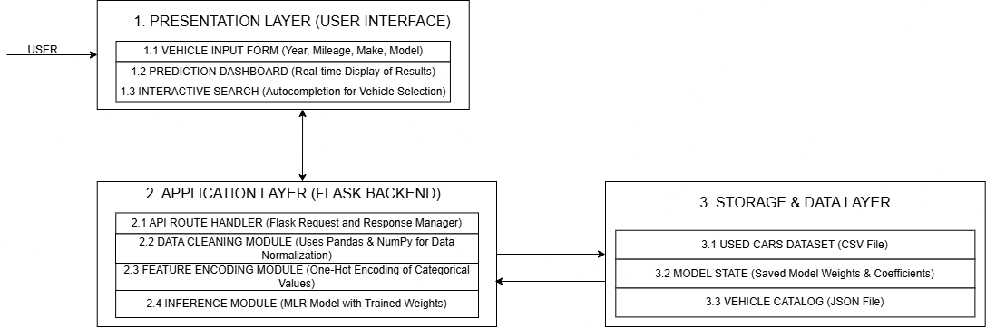
The system is developed using a modular approach to ensure a clean separation between the user interface and the core calculation logic. This decomposition allows for independent testing and debugging of each functional unit.

Figure 5.1 Different Modules of Car Resale Price Prediction System

5.1.2.1 Presentation Layer
This layer manages user interaction and displays the application interface.
- Template Module: Uses reusable Jinja2 templates such as base.html and _site_header.html to maintain a consistent page structure and navigation.
- Page Interface Module: Provides separate pages for Home, Estimator, About, Model Metrics, Login, Signup, Profile, Admin Dashboard, and records management.
- Styling Module: Uses styles.css to maintain a consistent, responsive, and user-friendly layout across different devices.
- Client-Side Validation Module: Uses main.js to validate login, signup, and estimator forms, manage mobile navigation, and display dynamic messages.
- Vehicle Autocomplete Module: Uses vehicleAutocomplete.js to load vehicle catalogues, suggest matching brands and models, support keyboard navigation, and validate brand-model combinations.

5.1.2.2 Authentication and Authorization Module
This module manages user registration, login sessions, role-based access, and account security.
- User Model: Extends UserMixin and stores hashed passwords instead of plaintext passwords.
- Signup Module: Validates the user’s name, email, password length, password confirmation, duplicate email, and CSRF token.
- Login Module: Performs a case-insensitive email search, verifies the password hash, creates a Flask-Login session, and redirects administrators to the dashboard.
- Authorization Module: Uses the admin_required decorator to restrict administrative routes and returns HTTP 403 for unauthorized access.
- Logout Module: Ends the active user session through a POST request protected by CSRF validation.
5.1.2.3 Prediction and Validation Module
This module validates submitted vehicle data and generates the resale price prediction.
- Prediction Route: The /predict route receives vehicle details through an HTML form submission.
- CSRF Protection: A session-based token is generated using secrets.token_urlsafe and verified with hmac.compare_digest.
- Server-Side Validation: Checks required fields, allowed categorical values, manufacturing year, numeric ranges, and valid brand-model combinations.
- Data Transformation: Converts valid input into a one-row DataFrame and processes it using FullPipeline.
- Model Prediction: Passes the transformed data to SGDRegressor under a threading lock.
- Result Calculation: Converts the logarithmic prediction back to NPR and uses the global MAE to calculate the lower and upper price range.
5.1.2.4 Similar-Car Recommendation Module
This module identifies and displays vehicles with characteristics similar to the predicted car.
- Dataset Filtering: Filters the reference dataset based on relevant vehicle attributes.
- Similarity Calculation: Uses weighted differences in year, engine capacity, and price to calculate a similarity score.
- Candidate Ranking: Sorts vehicles according to the calculated similarity score.
- Recommendation Output: Displays up to five similar vehicles with name, year, mileage, fuel type, transmission, historical price, and price difference.
5.1.2.5 Persistence and History Module
This module stores user accounts, predictions, and purchase-related information in PostgreSQL.
- Database Tables: Uses users and estimates tables to store account and prediction data.
- User-Estimate Relationship: SQLAlchemy relationships allow each user to access their saved estimates.
- Prediction Storage: Authenticated predictions store brand, model, year, fuel, transmission, predicted price, minimum price, maximum price, and creation time.
- Prediction History: The profile page displays saved estimates from newest to oldest.
- Detailed Specification Fields: The database includes additional vehicle fields required for purchase feedback.
- Known Limitation: The current prediction route does not populate all detailed specification fields needed for reliable model feedback.
5.1.2.6 Purchase Feedback Module
This module allows registered users to record the actual price paid for a predicted vehicle.
- Ownership Verification: Confirms that the selected estimate belongs to the authenticated user.
- Purchase Recording: Stores the actual purchase price and marks the estimate as bought.
- Database Update: Commits the updated purchase information to PostgreSQL.
- Model Feedback: Attempts to update the model using partial_fit with a learning rate equal to 5% of the main learning rate.
- Dataset Update: Attempts to append the feedback record to the CSV dataset.
- Current Limitation: Purchase information is stored reliably, but model fine-tuning remains experimental when detailed specifications are missing.
5.1.2.7 Administrative Module
This module provides role-restricted monitoring, reporting, and data-export functions.
- Dashboard Statistics: Displays regular user count, total predictions, predictions made during the current Nepal day, and average predicted price.
- Recent Activity: Shows the ten most recent prediction records.
- User Records: Provides a page listing all registered non-administrator users.
- Prediction Records: Provides a page containing all saved predictions.
- CSV Export: Generates and streams prediction_history.csv.
- Administrator Creation: A default administrator can be created using environment variables.
- Security Requirement: Default credentials and secret values should be replaced before production deployment.
5.1.2.8 Deployment and Runtime Module
This module defines the application runtime and deployment configuration.
- Python Runtime: runtime.txt specifies Python 3.11.10.
- Gunicorn Deployment: The Profile starts the application using gunicorn app:app.
- Vercel Configuration: vercel.json provides an alternative Python build and catch-all routing setup.
- Startup Training: The model trains whenever app.py is imported.
- Training Process: Startup includes data preprocessing and 450 training epochs before requests are served.
- Current Limitation: This approach is suitable for the prototype but should be replaced with a serialized model and controlled retraining process for multi-worker deployment.
5.1.3 Database and Security Implementation
Flask-SQLAlchemy initializes the database through a shared extension object, while Flask-Migrate records schema versions. The user.email field is unique, estimate.user_id is a foreign key, and the ORM relationship uses delete-orphan cascading. Database operations catch IntegrityError or SQLAlchemyError in account and history workflows and roll back failed transactions. Session cookies are configured as HttpOnly with SameSite=Lax. Safe relative redirect validation prevents open redirects through the next parameter. The implementation should additionally enable secure cookies over HTTPS, remove hard-coded fallback secrets, add login rate limiting, and apply CSRF validation to the purchase route in a future release.

5.2 Testing
5.2.1 Testing Strategy
Testing was organized at four levels.
- Unit Testing: Examined isolated preprocessing, regression, validation, and utility behavior.
- Integration Testing: Examined communication between routes, authentication, the database, the model, and templates.
- System Testing: Examined complete user and administrator workflows. Model evaluation used the held-out 20% test split and standard regression metrics.
The actual outputs below are based on the submitted source code, reproduced dataset analysis, available application screens, and direct inspection of route behavior. A status of Partial is used where the core action succeeds but an associated experimental step has a known limitation.
Table 5.5 Unit Test Cases
Test ID | Test Scenario | Expected Outcome
UT-01 | Apply feature engineering to a valid vehicle record. | Six derived features are created successfully.
UT-02 | Process a vehicle with seven seats. | The is_7_seater value is set to 1.
UT-03 | Fit the preprocessing pipeline using training data. | Feature columns, means, and standard deviations are stored.
UT-04 | Transform the testing dataset. | Training and testing data contain the same 1,942 feature columns.
UT-05 | Initialize the custom SGD regressor. | Coefficients are empty, and the intercept is initialized to zero.
UT-06 | Train the SGD model using valid synthetic data. | Training completes with the correct coefficient dimensions.
UT-07 | Generate predictions for ten input records. | The model returns ten prediction values.
UT-08 | Submit an unsafe external redirect URL. | The external URL is rejected, and a safe internal route is used.
UT-09 | Submit a manufacturing year outside the allowed range. | The system displays a year-validation error.
UT-10 | Submit an unsupported seating option. | The system rejects the input and displays a validation message.
UT-11 | Request similar-car recommendations. | The system returns no more than five ranked vehicles.
UT-12 | Store and verify a user password. | The password is hashed and can be verified correctly.
Table 5.6: Integration Test Cases
Test ID | Test Scenario | Expected Outcome
IT-01 | Register a user with valid and unique account details. | A user record is created, the password is hashed, and a session begins.
IT-02 | Log in using regular-user and administrator accounts. | Regular users reach their profile, while administrators reach the dashboard.
IT-03 | Request the vehicle catalogue API. | The endpoint returns dataset-based brands and models in JSON format.
IT-04 | Submit a valid prediction request as a guest. | The result page displays the price, range, and similar cars without saving the estimate.
IT-05 | Submit a valid prediction while authenticated. | The estimate is saved and displayed in the user’s prediction history.
IT-06 | Submit missing or out-of-range estimator values. | The form displays field-level errors and does not generate a prediction.
IT-07 | Record an actual purchase price for an owned estimate. | The purchase information is saved, and model feedback is attempted.
IT-08 | Attempt to update another user’s estimate. | The request is rejected with HTTP 403, and no data is changed.
IT-09 | Open user and prediction records as an administrator. | Complete database records are displayed on protected admin pages.
IT-10 | Export prediction history as an administrator. | A CSV file containing headers and prediction records is generated.

Table 5.7: System Test Cases
Test ID | Test Scenario | Expected Outcome
ST-01 | Complete the vehicle-estimation process as a guest. | The system displays the predicted price, price range, and similar vehicles.
ST-02 | Sign up, generate a prediction, and review history. | The account is created, and the saved estimate appears in the profile.
ST-03 | Complete the administrator workflow. | Admin pages load successfully, and non-admin access is blocked.
ST-04 | Use the application on desktop and mobile screen sizes. | Navigation, forms, and content adapt without losing functionality.
ST-05 | Submit invalid authentication and estimator data. | Client-side errors appear, and the server independently rejects invalid submissions.
ST-06 | Start or import the Flask application. | The dataset loads, the model trains, and metrics and catalogue data become available.
ST-07 | Restart the application after database records exist. | PostgreSQL records remain available, while the model retrains from the CSV file.
ST-08 | Run multiple Gunicorn workers and submit model feedback. | All workers should use the same updated model state.

5.2.2 Model Evaluation Results
Table 5.8: Model Evaluation Results
Measure | Result | Interpretation
R² | 0.8702 | The model explains approximately 87.02% of the observed variance in valid test predictions.
MAE | NPR 181,277.83 | Average absolute difference between actual and predicted prices.
MSE | 79,332,954,778.29 | Average squared error in NPR².
RMSE | NPR 281,661.06 | Square-root error measure in NPR; larger than MAE because large errors receive greater weight.
MAPE | 18.23% | Average absolute percentage difference for valid test predictions.
Training records | 5,431 | 80% sample after cleaning and outlier filtering.
Testing records | 1,358 | 20% hold-out records.
Encoded features | 1,942 | Features generated by the submitted preprocessing pipeline.
Missing test predictions | 55 | Rows affected by incomplete transform-time numeric handling; current pandas metric aggregation skips missing values.

The R² result is the most appropriate percentage-style summary of the regression model: 0.8702 corresponds to 87.02% explained variance, not classification accuracy. MAE and RMSE show that meaningful price error remains, particularly for high-value or unusual vehicles. The MAPE of 18.23% indicates that the typical proportional error is under one fifth for the valid evaluated predictions. The 55 missing test predictions reveal an implementation issue in transform-time imputation and must be addressed before production deployment. Consequently, the results demonstrate a strong academic prototype while also defining a clear area for technical improvement.
5.3 Dataset Characteristics
UsedCars.csv is the main source for training, validation limits, brand/model suggestions, similar-car lookup, and optional feedback append operations. The submitted file contains 8,131 rows and 13 original columns. A total of 1,202 duplicate rows are present in the raw file. After duplicate removal and price outlier filtering, 6,789 rows remain for model development.
Table 5.9: Dataset Attribute Description
Attribute | Data Type | Description
name | String | Full vehicle name; also used to derive brand and model.
year | Integer | Manufacturing year, 1983 to 2020.
selling_price | Numeric | Historical selling price in INR before conversion to NPR.
km_driven | Integer | Distance driven in kilometres.
fuel | Categorical | Diesel, Petrol, CNG, or LPG.
seller_type | Categorical | Individual, Dealer, or Trustmark Dealer.
transmission | Categorical | Manual or Automatic.
owner | Categorical | First, Second, Third, or Fourth & Above Owner.
mileage | String/Numeric | Fuel efficiency with kmpl unit in the raw CSV.
engine | String/Numeric | Engine displacement with CC unit in the raw CSV.
max_power | String/Numeric | Maximum power with bhp unit in the raw CSV.
torque | String | Inconsistent torque description; removed before training.
seats | Float | Seating capacity.

Table 5.1.1: Dataset Characteristics Summary
Property | Value
Raw records | 8,131
Original attributes | 13
Duplicate rows in raw CSV | 1,202
Rows after duplicate and target-outlier filtering | 6,789
Dataset brands | 32
Distinct model strings before grouping | 2,058
Year range | 1983-2020
Raw price range | INR 29,999-INR 10,000,000
Missing mileage values | 221
Missing engine values | 221
Missing max_power values | 215
Missing seats values | 224
Training split | 5,431 records
Testing split | 1,358 records
Encoded feature count | 1,942
Target currency in application | NPR using fixed multiplier 2.2

CHAPTER 6: CONCLUSION AND FUTURE RECOMMENDATIONS

6.1 Conclusion

The project successfully achieved its objective of developing a web-based used-car resale price prediction system. A custom Multiple Linear Regression model optimized with Mini-Batch Stochastic Gradient Descent was implemented using data cleaning, feature engineering, encoding, standardization, logarithmic target transformation, L2 regularization, and an 80:20 train-test split. The Flask application allows users to enter 12 vehicle characteristics, receive a resale price estimate in NPR, view an MAE-based price range, and compare similar vehicles. It also includes authentication, prediction history, PostgreSQL storage, purchase-price recording, administrator statistics, and CSV export.

Unit, integration, system, and model-performance testing were conducted. The model achieved R² = 0.8702, MAE = NPR 181,277.83, RMSE = NPR 281,661.06, and MAPE = 18.23%, explaining approximately 87.02% of the variation in vehicle prices. Overall, the project demonstrates the successful integration of machine learning, web development, database management, authentication, validation, and recommendation features, providing a functional academic prototype and a foundation for a more advanced Nepal-specific valuation system.

6.2 Future Recommendations
Future development should focus on improving data quality, model accuracy, and inference reliability. A verified Nepal-specific dataset should include local prices, taxes, import details, province, vehicle condition, accident history, and service records. The fixed INR-to-NPR conversion should be replaced with direct NPR prices or dated exchange-rate data. Preprocessing should be corrected by applying training-time imputation and categorical encoding consistently during prediction, removing unsupported raw fields, and expanding seating options. The current model should also be compared with Ridge, Lasso, Random Forest, Gradient Boosting, XGBoost, CatBoost, and neural networks using cross-validation. Image-based condition assessment and explainability methods such as coefficient summaries or SHAP values could further improve transparency.
The fitted pipeline and model should be serialized, versioned, and retrained through a controlled process rather than during every application startup. All vehicle specifications should be stored with each estimate, and purchase feedback should be validated before model updates. A centralized model service or shared artifact store would improve consistency across multiple workers. Security should be strengthened by removing fallback credentials, enabling secure cookies, applying CSRF protection to all state-changing routes, and adding rate limiting, email verification, password reset, audit logging, and account-lockout controls. A complete automated testing process using pytest, Flask test fixtures, a temporary database, continuous integration, and coverage reporting is also recommended.

REFERENCES
[1] S. Raghav, “Used Car Price Prediction using Machine Learning,” International Journal for Research in Applied Science and Engineering Technology, vol. 11, no. 5, pp. 2452-2457, 2023.
[2] S. Lessmann and S. Voß, “Car resale price forecasting: The impact of regression method, private information, and heterogeneity on forecast accuracy,” International Journal of Forecasting, vol. 33, no. 4, pp. 864-877, 2017, doi: 10.1016/j.ijforecast.2017.04.003.
[3] F. Abdullah, M. A. Rahman, M. Shidujaman, M. Hasan, and M. T. Habib, “Machine learning modeling for reconditioned car selling price prediction,” Proceedings of SPIE, vol. 12779, Art. no. 1277925, 2023, doi: 10.1117/12.2689745.
[4] E. Gegic, B. Isakovic, D. Keco, Z. Masetic, and J. Kevric, “Car Price Prediction using Machine Learning Techniques,” TEM Journal, vol. 8, no. 1, pp. 113-118, 2019, doi: 10.18421/TEM81-16.
[5] N. Monburinon, P. Chertchom, T. Kaewkiriya, S. Rungpheung, S. Buya, and P. Boonpou, “Prediction of prices for used car by using regression models,” in 2018 5th International Conference on Business and Industrial Research (ICBIR), Bangkok, Thailand, 2018, pp. 115-119, doi: 10.1109/ICBIR.2018.8391177.
[6] A. Zhu, “Pre-Owned Car Price Prediction Using Machine Learning Techniques,” in Proceedings of the 1st International Conference on Data Analysis and Machine Learning (DAML 2023), pp. 356-360, 2024, doi: 10.5220/0012810100003885.
APPENDIX
Screenshot 1: Home Page
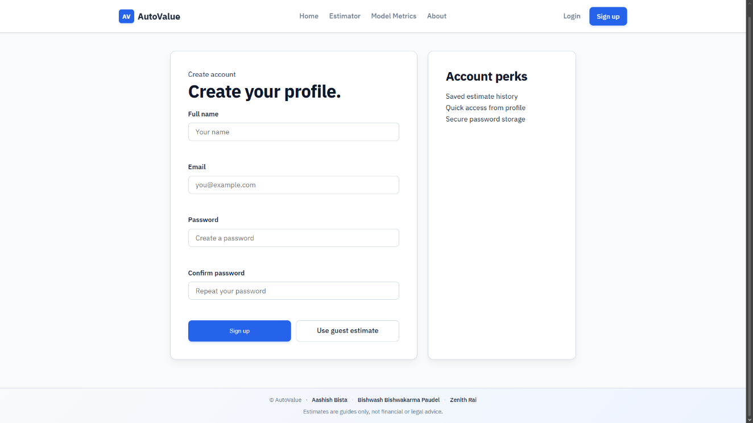
Screenshot 2: SignUp Page

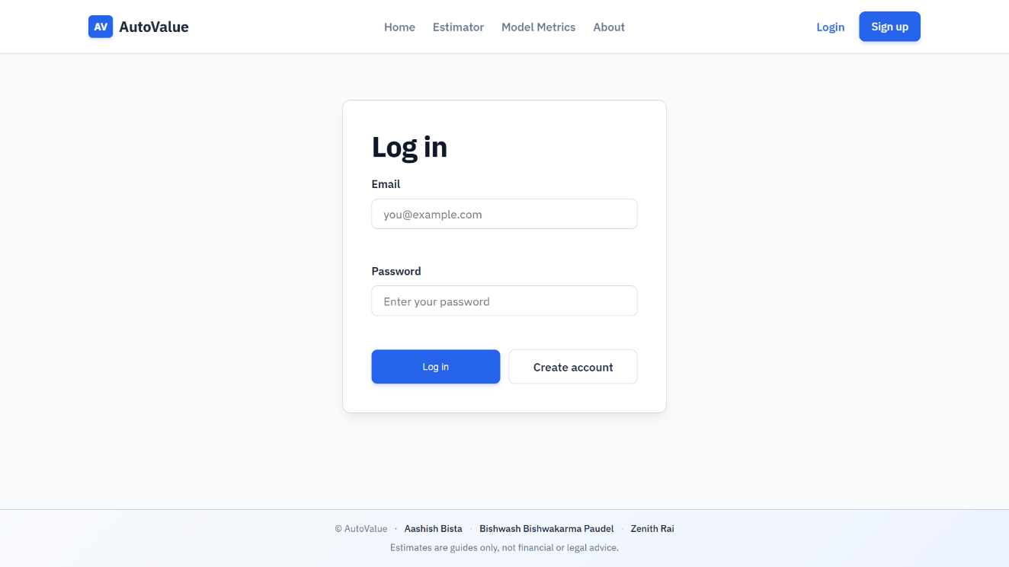
Screenshot 3: Login Page

Screenshot 4: About Page

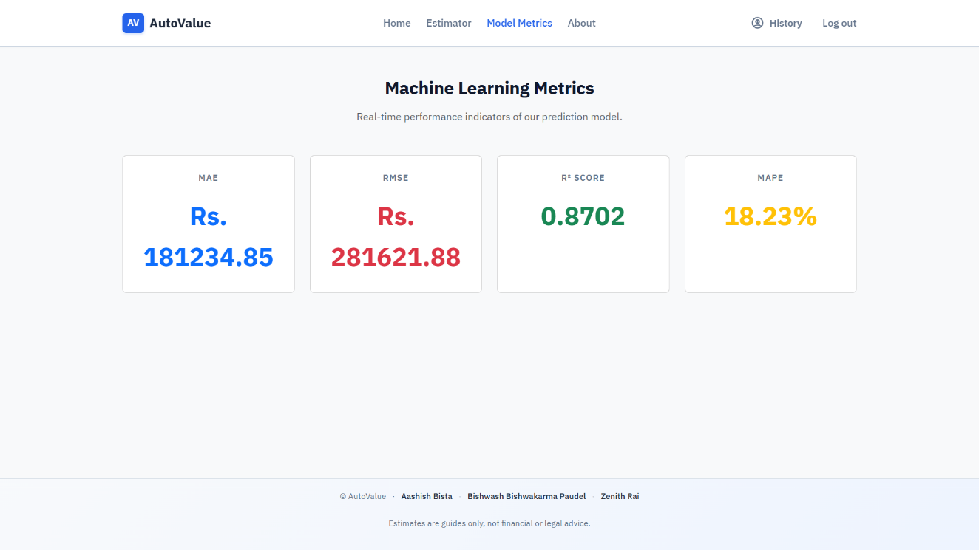
Screenshot 5: Model Metrics Page
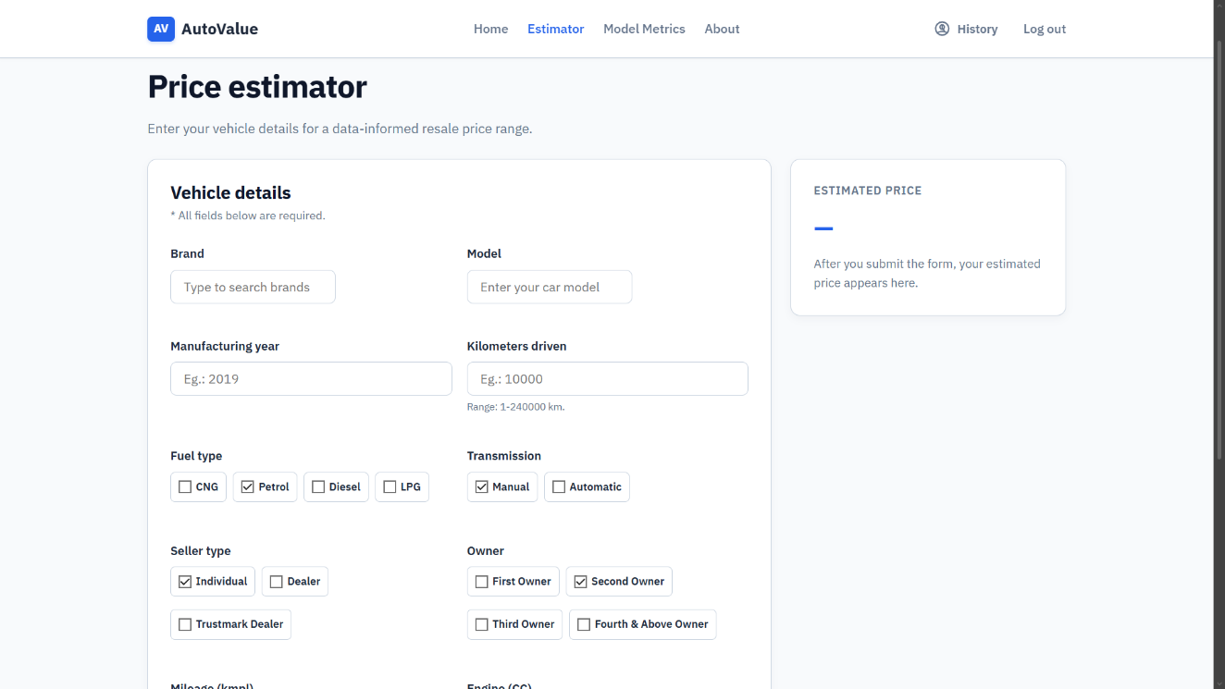
Screenshot 6: Estimator Page

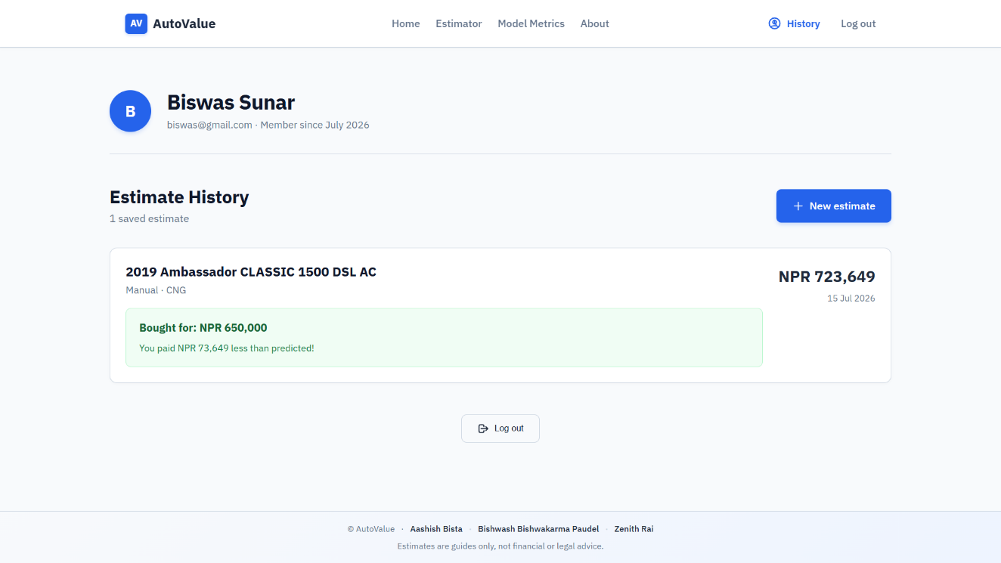
Screenshot 7: Estimate History Page
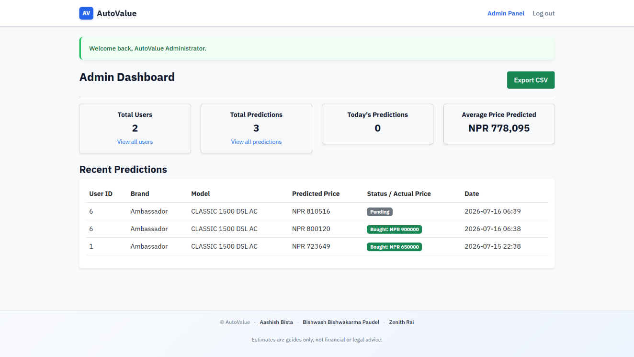
Screenshot 8: Admin Dashboard

